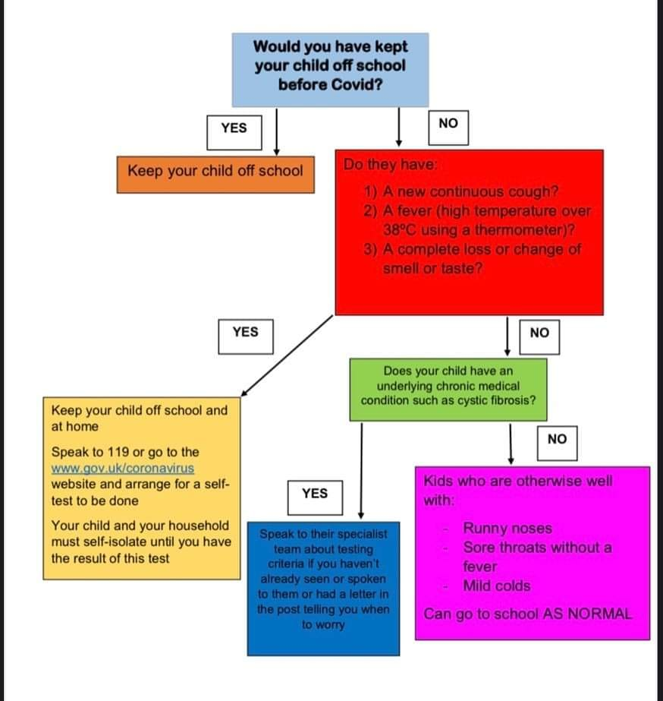
This is official guidance from the Royal College of Paediatrics and Child Health – shared on Facebook by a parent I know who works for the NHS.

