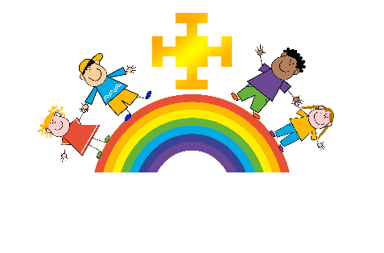

Religious Education – Vision for children at St Chad’s Primary, Lichfield
‘For every child to have an understanding of beliefs, practises and values of Christianity and other faiths; having the ability to make reasoned, informed judgements, ask questions that impact their lives and to have a deep understanding of the evolving world in which we live and people we relate to’
- Hannah Prime-R.E Leader-
Intent
St Chad’s C of E Primary School R.E curriculum aims to ensure that all pupils are able to:

- To reflect theologically and explore the ultimate questions and challenges of life in today’s society.
- To reflect critically on the truth claims of Christian belief.
- To see how the truth of Christianity is relevant today.
- To develop the skills to handle the Bible text.
- To recognise that faith is based on commitment to a particular way of understanding God and the world.
- To learn about other world faiths.
- To engage in thoughtful dialogue with other faiths and traditions.
- To begin to develop their own commitments, beliefs and values.
- To develop a sense of themselves as significant, unique and precious.
- To have a deep, secure knowledge and understanding of all faiths and people in our world which can then be built on further, as they move on to secondary school and that they can draw upon in their daily lives.
Implementation
- All children are entitled to the RE curriculum at St Chads. Families have the right to withdraw themselves from the RE curriculum.
- R.E teaching takes place weekly across the school by the class teacher following a conceptual enquiry approach with 2/3 of the teaching time spent exploring key Christian concepts through the use of the scheme ‘Understanding Christianity.’ The 1/3 of remaining teaching time is learning and developing a deep understanding of other world faiths through the use of the scheme ‘Discovery RE.’ Both of these teaching resources aim to develop ‘theologically literate’ pupils.
- A variety of teaching methods are used to teach RE including making cross curricular links where appropriate.
- The RE units are taught in half termly blocks.
- The curriculum follows a spiral curriculum with key Christian concepts being further developed to a deeper level higher up the school.
- Other world faiths are delivered in a structured way with opportunities to visit places of worship. (The Derby Faith Trail)
- Also during November we have an ‘Interfaith Week,’ where we invite people from other faiths to share their beliefs and practises and there is a weekly focus on learning about people from all faiths of life.
- Every child, when joining St Chad’s is given their own Bible.
- Assessment for learning opportunities are carried out in R.E through teaching, which allows children to build on prior learning, progress and excel throughout their time at St Chad’s.

The R.E Curriculum provides the opportunity to:
- Listen to the opinion of others, developing empathy
- Consider their own attitudes and personal beliefs
- Develop questioning skills and evaluate evidence
- Develop a secure understanding of moral issues

British values are an integral part of the R.E curriculum. Pupils explore religious beliefs and the impact on the people following that religion. They are given opportunities to make connections between their own life experiences and understanding of the world. These skills we hope to promote the children at St Chads with tolerance and mutual respect of the opinions of others and an appreciation of democracy and the rule of law.

Impact
- Our aim is to have an R.E curriculum that provides challenging, thought provoking planned learning opportunities and skills not only to make excellent progress but for all of our children to use in everyday real life
- For every child leaving St Chad’s to be well prepared for their transition to RE learning in secondary school and developed their own set of beliefs about the world and who they are as individuals
- Children have developed their own spirituality and ask ‘BIG’ questions
- Children have the knowledge and understanding to live successfully in a multicultural society
- R.E is assessed half termly against specified outcomes from the schemes of work being followed. These are taken in every half term by the subject leader and analysed to ensure all children make maximum progress and become ‘Religiously literate.’

