If you are having to self-isolate at home, this is what you can expect from school:

- Lessons and resources will be provided for each day which will closely match what you would have been doing in school. The lessons and resources will be usually in the form of links to recorded lessons on the Oaks National Academy website/White Rose Maths.

- Lessons will be made available to you through email, Youtube & J2E.

- If you don’t have access to the right technology at home. Don’t worry, please let school know. The school will deliver to you a pack of work that needs to be completed during the duration that you’re self-isolating.

- Your teachers have looked closely at the lessons that you are missing. They have identified lesson links and resources, so that you don’t miss out.

- You will get a well-being call during the time that you are off. We care about how you’re feeling and will make sure that we can help in anyway if needed.

- If you have an identified learning need, one of our learning support assistants will contact you to make sure that you understand the work that has been set. We don’t want you to feel frustrated and anxious with the work to be completed at home.

- We would recommend that you read a book independently or with your parents during the period of self-isolation. Reading helps to expand your vocabulary and access your work better in school.

- On return to school, your teacher will be keen to discuss your learning and ensure that you have understood the work completed before moving on.

AND If the class bubble/ year group has to close and you have to work from home, you will continue to follow the lessons on your school timetable:

- The majority of lessons and resources will be from our teachers and some from the Oak National Academy/White Rose Maths.

- Your lessons and resources will be emailed daily by your teachers. Your teachers will upload videos onto our Youtube channel for you to learn from. Your teacher will let you know about those.

- While learning at home, there will be times when pupils in key stage 2 may be asked to complete online quizzes. It is expected that you complete and submit these as instructed by your teacher. From these, your teacher will be able to evaluate how well you’ve understood the work and if needed reteach topics that our pupils are finding difficult.

- We would recommend that you read a book independently or with your parents during the period of school closure. Reading helps to expand your vocabulary and access your work better in school.

- Please don’t worry during the period at home. Your teachers are working hard to ensure that you keep on top of your work. You will receive a call from a support member of staff to find out how you are.

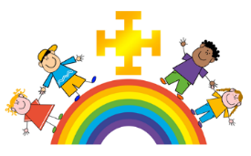
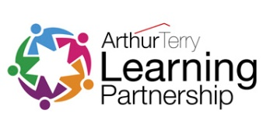
St Chad’s CE (VC) Primary School
COVID-19: Information for Primary Pupils and their Parents/Carers

What school expects from you:

- Complete each lesson on paper/ online as directed by your teacher. For most lessons you will need a pen or pencil and a ruler. Make sure that you have these ready. Complete them as best as you can, if you are finding it challenging, let your teacher know using agreed communication channels.

