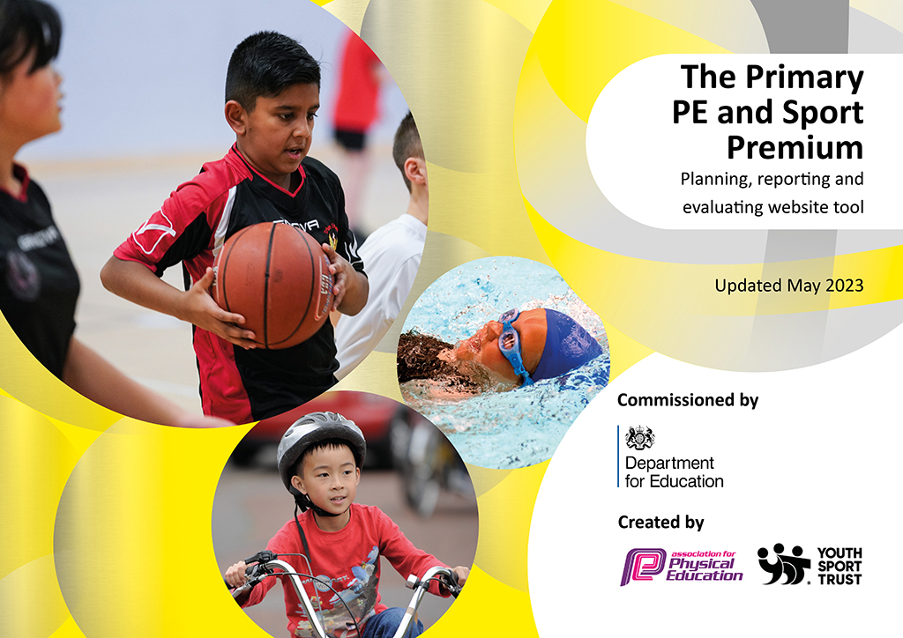
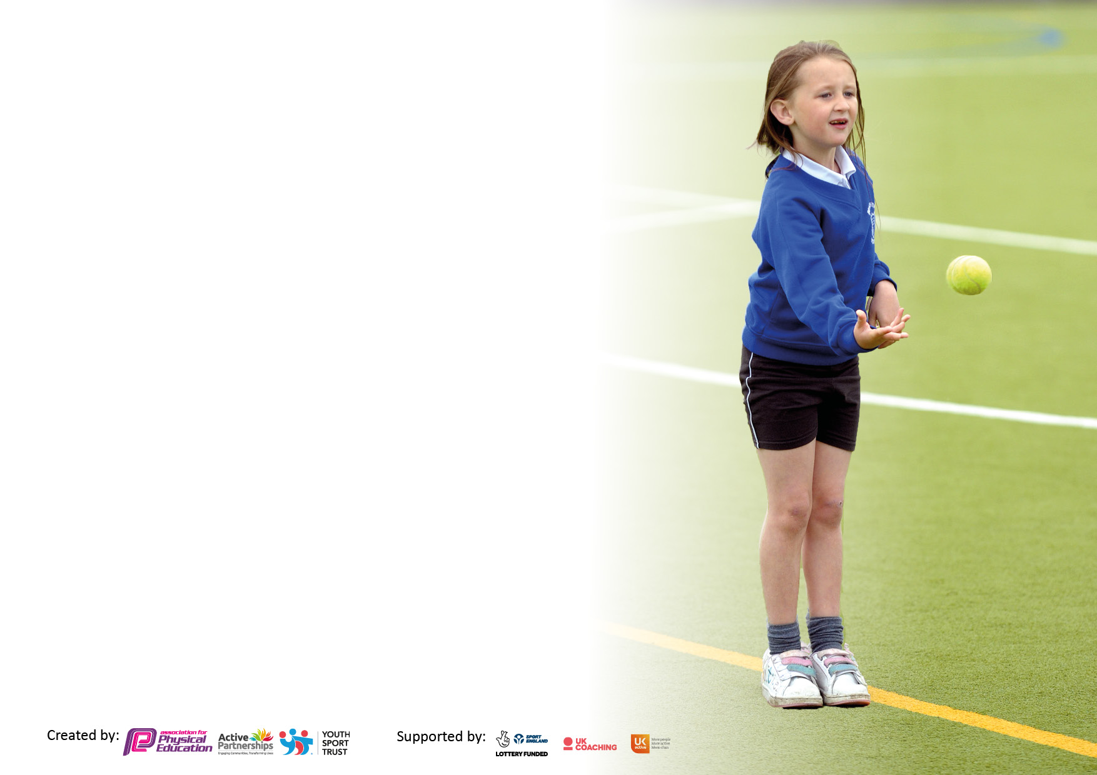

It is important that your grant is used effectively and based on school need. The Education Inspection Framework makes clear there will be a focus on ‘whether leaders and those responsible for governors all understand their respective roles and perform these in a way that enhances the effectiveness of the school’.

Under the Quality of Education Ofsted inspectors consider:
Intent - Curriculum design, coverage and appropriateness
Implementation - Curriculum delivery, Teaching (pedagogy) and Assessment
Impact - Attainment and progress

To assist schools with common transferable language this template has been developed to utilise the same three headings which should make your plans easily transferable between working documents.

Schools must use the funding to make additional and sustainable improvements to the quality of Physical Education, School Sport and Physical Activity (PESSPA) they offer. This means that you should use the Primary PE and sport premium to:

- Develop or add to the PESSPA activities that your school already offer
- Build capacity and capability within the school to ensure that improvements made now will benefit pupils joining the school in future years
- The Primary PE and sport premium should not be used to fund capital spend projects; the school’s budget should fund these.

Pleasevisitgov.ukfortherevisedDfEguidanceincludingthe5keyindicatorsacrosswhichschoolsshoulddemonstrate animprovement.Thisdocumentwillhelpyoutoreviewyourprovisionandtoreportyourspend.DfEencouragesschools to use this template as an effective way of meeting the reporting requirements of the Primary PE and Sport Premium.

We recommend you start by reflecting on the impact of current provision and reviewing the previous spend.

Schools are required to publish details of how they spend this funding, including any under-spend from 2021/2022, as well as on the impact it has on pupils’ PE and sport participation and attainment. All funding must be spent by 31st July 2023.

We recommend regularly updating the table and publishing it on your website throughout the year. This evidences your ongoing self-evaluation of how you are using the funding to secure maximum, sustainable impact. Final copy must be posted on your website by the end of the academic year and no later than the 31st July 2023. To see an example of how to complete the table please click HERE.

Details with regard to funding
Please complete the table below.

Total amount carried over from 2021/22 | £10,360
Total amount allocated for 2021/22 | £17,810
How much (if any) do you intend to carry over from this total fund into 2022/2023 | £0
Total amount allocated for 2022/23 | £17,870
Total amount of funding for 2022/23 to be spent and reported on by 31st July 2023. | £13,730
Swimming Data
Please report on your Swimming Data below.

Meeting national curriculum requirements for swimming and water safety.

N.B. Complete this section to your best ability. For example you might have practised safe self-rescue techniques on dry land which you can then transfer to the pool when school swimming restarts.
Due to exceptional circumstances priority should be given to ensuring that pupils can perform safe self rescue even if they do not fully meet the first two requirements of the NC programme of study
What percentage of your current Year 6 cohort swim competently, confidently and proficiently over a distance of at least 25 metres?  N.B. Even though your pupils may swim in another year please report on their attainment on leaving primary school at the end of the summer term 2022.  Please see note above | 90%
What percentage of your current Year 6 cohort use a range of strokes effectively [for example, front crawl, backstroke and breaststroke]?  Please see note above | 85%
What percentage of your current Year 6 cohort perform safe self-rescue in different water-based situations? | 76 %
Schools can choose to use the Primary PE and sport premium to provide additional provision for swimming but this must be for activity over and above the national curriculum requirements. Have you used it in this way? | Yes/No

Action Plan and Budget Tracking
Capture your intended annual spend against the 5 key indicators. Clarify the success criteria and evidence of impact that you intend to measure to evaluate for pupils today and for the future.

Academic Year: 2022/23 | Total fund allocated:£3,888 | Date Updated: 12/7/23
Key indicator 1: The engagement of all pupils in regular physical activity – Chief Medical Officers guidelines recommend that primary school pupils undertake at least 30 minutes of physical activity a day in school |  |  |  | Percentage of total allocation:
 |  |  |  | 35%
Intent | Implementation |  | Impact
Your school focus should be clear what you want the pupils to know and be able to do and about  what they need to learn and to  consolidate through practice: | Make sure your actions to achieve are linked to your intentions: | Funding allocated: | Evidence of impact: what do pupils now know and what can they now do? What has changed?: | Sustainability and suggested next steps:
To ensure inclusion of all children in activities during break and lunch  To make break and lunchtimes more opportune for physical activity | Progressive sports support at lunchtimes to increase physical activity levels  Lunchtime football clubs to promote good sports-personship and promote physical activity with Aston Villa coaches  Small group work at lunchtimes with disadvantaged children with specialist sport LSA | £3,888 | All children have become more involved in physical activity at lunch times  Supported relationships and team skills with small groups of children  Football clubs promote skills based learning as well as resilience and fitness | Consistency with lunchtime clubs to support small groups of children  Football clubs to be continued with Aston Villa  Seeking ATLP funding for more multi- purpose sports facilities
Key indicator 2: The profile of PESSPA being raised across the school as a tool for whole school improvement |  |  |  | Percentage of total allocation:
 |  |  |  | 0% (£7,450 allocated previous year)
Intent | Implementation |  | Impact
Your school focus should be clear what you want the pupils to know and be able to do and about  what they need to learn and to  consolidate through practice: | Make sure your actions to achieve are linked to your intentions: | Funding allocated: | Evidence of impact: what do pupils now know and what can they now do? What has changed?: | Sustainability and suggested next steps:
Implementation of consistent outdoor learning opportunities for all children | The money that has been previously used to fund Forest School training has enabled Forest Schools to be provided to all children of all ages across the year  ‘A night under the stars’ was implemented to provide children with enrichment opportunities and outdoor learning | £0 | Children have been able to develop holistically, build resilience as well as connect with nature to develop their ownership of the environment. | Continue to develop the FS ethos and provision across the school  Potential holiday club- focusing on supporting DAPs

Key indicator 3: Increased confidence, knowledge and skills of all staff in teaching PE and sport |  |  |  | Percentage of total allocation:
 |  |  |  | 45%
Intent | Implementation |  | Impact
Your school focus should be clear | Make sure your actions to | Funding | Evidence of impact: what do | Sustainability and suggested
what you want the pupils to know | achieve are linked to your | allocated: | pupils now know and what | next steps:
and be able to do and about | intentions: |  | can they now do? What has
what they need to learn and to |  |  | changed?:
consolidate through practice:
To develop the subject knowledge of all staff (Y1,3,5,6) and give them the opportunities to develop their practice. | Sports coaches from Aston Villa will be delivering CPD through PE sessions with the children and staff.  Provided additional resources for staff CPD. | £9,842 | Children have a much better understanding of the different skills- rather than sessions being game based. The children know the 3 main areas of ABC and how they are incorporated in each session.  There has been a big focus of- look, travel, evade and see, defend, attack with less of a focus on | Continuation of support from Aston Villa to those who have not received CPD
Key indicator 4: Broader experience of a range of sports and activities offered to all pupils |  |  |  | Percentage of total allocation:
Intent | Implementation |  | Impact
Your school focus should be clear | Make sure your actions to | Funding | Evidence of impact: what do | Sustainability and suggested
what you want the pupils to know | achieve are linked to your | allocated: | pupils now know and what | next steps:
and be able to do and about | intentions: |  | can they now do? What has
what they need to learn and to |  |  | changed?:
consolidate through practice:
Provide opportunities for children to engage in sporting activities that they would not normally engage in. | Aston Villa coaches to provide a range of sports to engage and interest children  Involvement in additional competitions outside of school; athletics, football, tennis coaching (free LTA)  Liaising with other schools within the trust; Nether Stowe Sports day Y4, Y5/6 transition sporting activities.  Extra-curricular clubs including- skateboarding, competitive sports, archery, handball, dodgeball, football, tennis. | £2376 (included in total ost) | Engagement and enthusiasm has been increased across the school.  Children’s fitness and physical well-being has been well promoted  Children have developed their interest in new sports | Continue to provide sporting and enrichment opportunities into the next academic year

Key indicator 5: Increased participation in competitive sport |  |  |  | Percentage of total allocation:
 |  |  |  | 0%
Intent | Implementation |  | Impact
Your school focus should be clear | Make sure your actions to | Funding | Evidence of impact: what do | Sustainability and suggested
what you want the pupils to know | achieve are linked to your | allocated: | pupils now know and what | next steps:
and be able to do and about | intentions: |  | can they now do? What has
what they need to learn and to |  |  | changed?:
consolidate through practice:
Provide opportunities for all children to be able to take part in competitive sports. | The school to take part in: sports days (internal and external), athletics competitions, football matches and tennis coaching | £0 | Year 5/6 children have taken part in an athletic competition where they got to the final- they have developed confidence, experience and resilience by taking part. | Enrichment clubs to continue next year  Enrichment and PE faculties to liaise with each other to organise extra-curricular opportunities to be involved in competitions.

Signed off by
Head Teacher:
Date: | 12/7/23
Subject Leader:
Date: | 12/7/23
Governor:
Date: | 12/7/23

