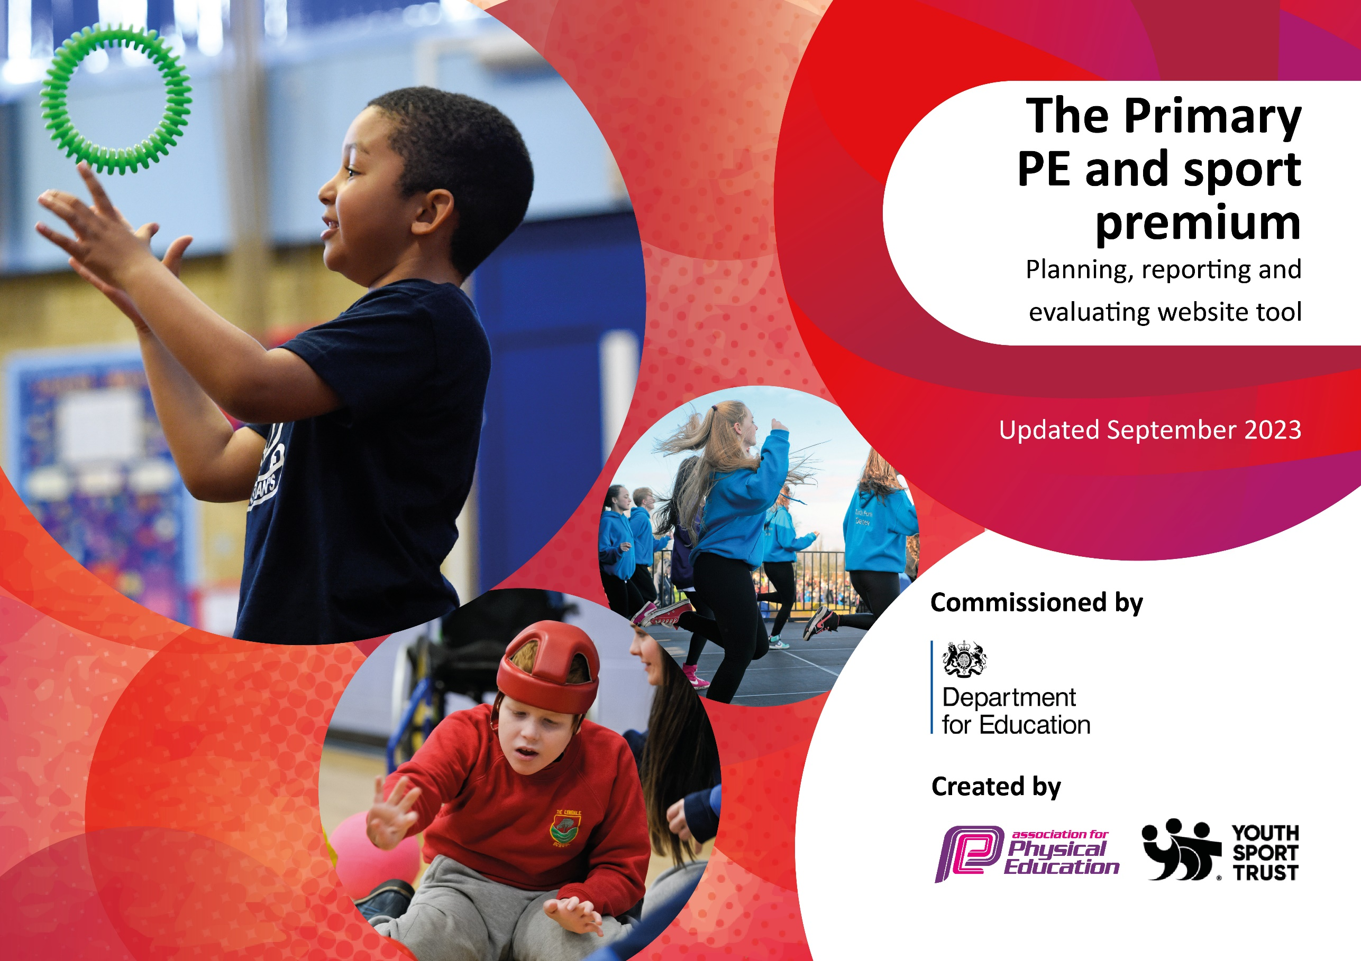

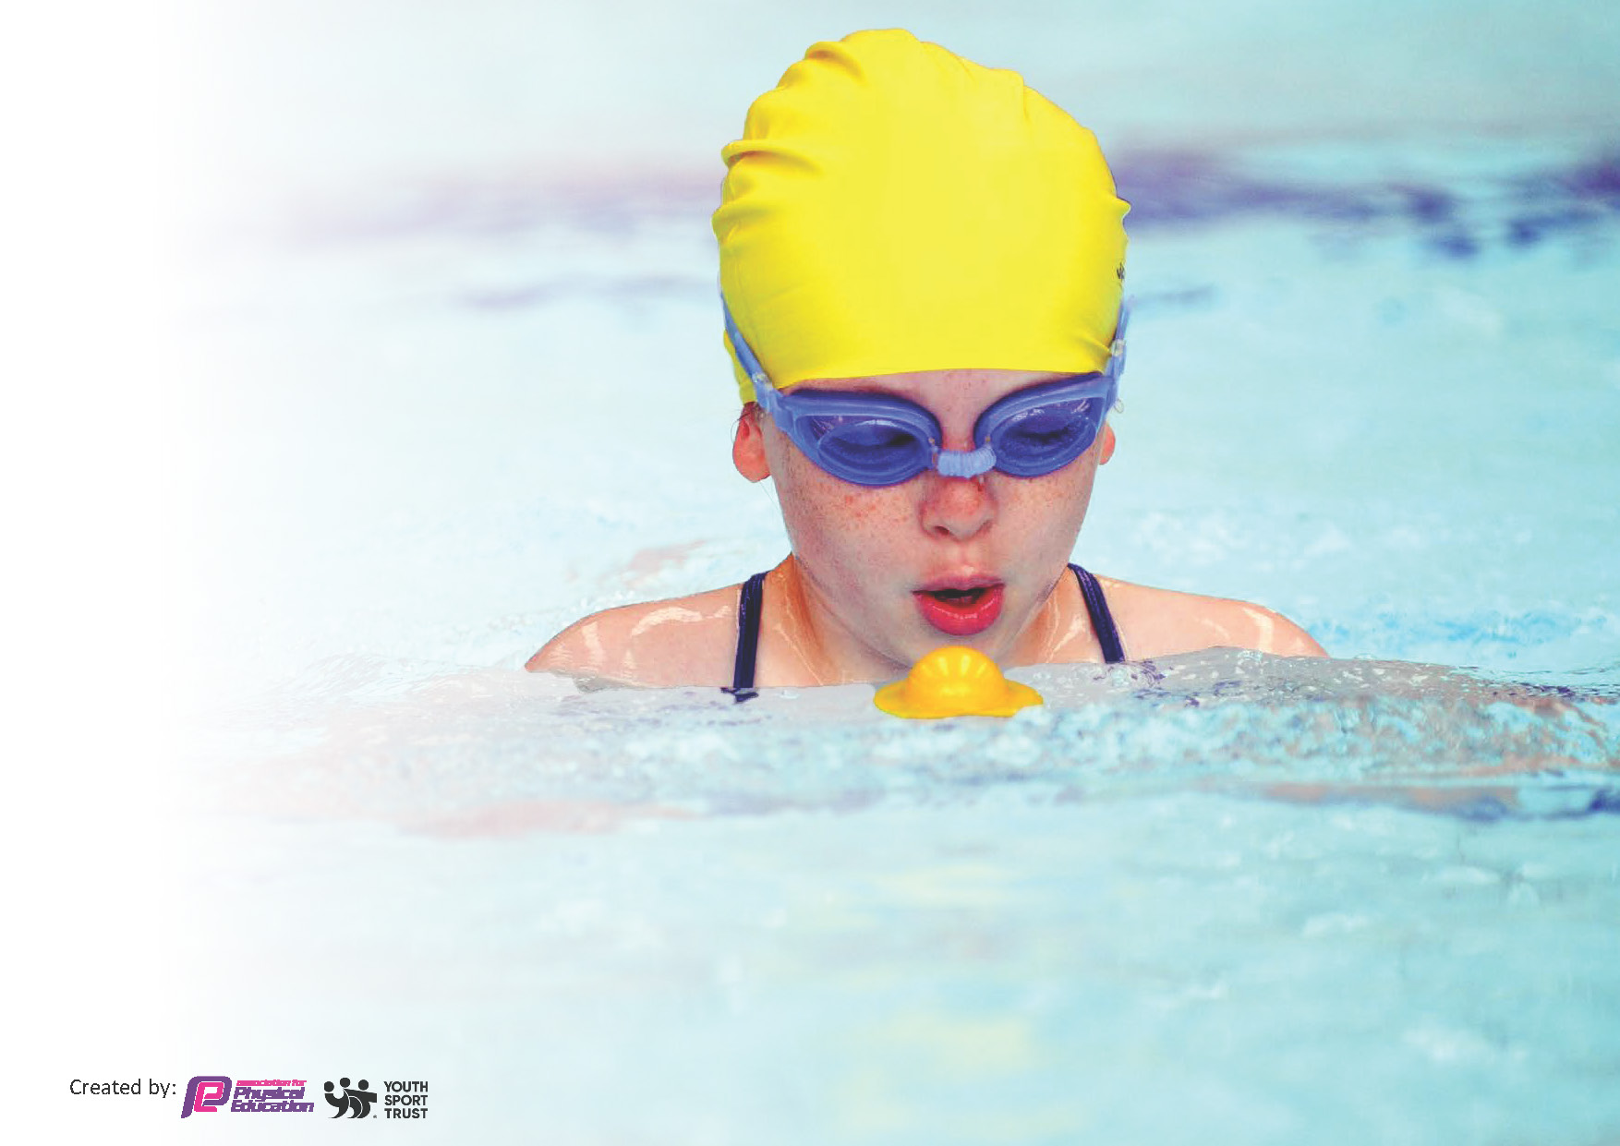
This template can be used for multiple purposes:
by:
- It enables schools to effectively plan their use of the Primary PE and sport premium
- It helps schools to meet the requirements (as set out in guidance) to publish information on their Primary PE and sport premium
- It will be an effective document to support Ofsted inspections enabling schools to evidence progress in Physical Education (PE) and evidence swimming attainment, which forms part of the PE National Curriculum. We would recommend schools consider
the Intent, Implementation and Impact of any spend, as examined within the Education Inspection Framework.

It is important that your grant is used effectively and based on school need.

Schools must use the funding to make additional and sustainable
improvements to the quality of the PE, School Sport and Physical Activity (PESSPA)
they offer. This means that you should use the Primary PE and sport premium to:

- Build capacity and capability within the school to ensure that improvements made now will benefit pupils joining the school in future years
- Develop or add to the PESSPA activities that your school already offers.

The Primary PE and sport premium should not be used to fund capital spend projects; the school’s core budget should fund these. Further detail on capital expenditure can be found in the updated Primary PE and sport premium guidance.

The Primary PE and sport premium guidance, outlines 5 key priorities that funding should be used towards. It is not

necessary that spending has to meet all the key priorities, you should select the priorities that you aim to use any funding towards.

Although completing this template is not a requirement for schools, schools are required to publish details of how they spend this funding. Schools must also outline what the impact this funding has had on pupils’ PE and sport participation and attainment and how any spending will be sustainable in the future. All funding must be spent by 31st July 2024.

The Department for Education has worked closely with the Association for Physical Education (afPE) and the Youth Sport Trust (YST) to develop this template and encourages schools to use it. This template is an effective way of meeting the reporting requirements of the Primary PE and sport premium.

Review of last year’s spend and key achievements (2023/2024)

Activity/Action | Impact | Comments
To ensure inclusion of all children in activities during break and lunch  To make break and lunchtimes more opportune for physical activity  Implementation of consistent outdoor learning opportunities for all children  To develop the subject knowledge of all staff (Y1,3,5,6) and give them the opportunities to develop their practice.  Provide opportunities for children to engage in sporting activities that they would not normally engage in.  Provide opportunities for all children to be able to take part in competitive sports. | All children have become more involved in physical activity at lunch times  Supported relationships and team skills with small groups of children  Football clubs promote skills based learning as well as resilience and fitness  Children have been able to develop holistically, build resilience as well as connect with nature to develop their ownership of the environment.  Children have a much better understanding of the different skills- rather than sessions being game based. The children know the 3 main areas of ABC and how they are incorporated in each session.  There has been a big focus of- look, travel, evade and see, defend, attack with less of a focus on.  Engagement and enthusiasm has been increased across the school.  Children’s fitness and physical well-being has been well promoted  Children have developed their interest in new sports  Year 5/6 children have taken part in an athletic competition where they got to the final- they have developed confidence, experience and resilience by taking part. | Consistency with lunchtime clubs to support small groups of children  Football clubs to be continued with Aston Villa  Continue to develop the FS ethos and provision across the school  Continuation of support from Aston Villa to those who have not received CPD  Continue to provide sporting and enrichment opportunities into the next academic year  Enrichment clubs to continue next year  Enrichment and PE faculties to liaise with each other to organise extra-curricular opportunities to be involved in competitions.

Key priorities and Planning
This planning template will allow schools to accurately plan their spending.

Action – what are you planning to do | Who does this action impact? | Key indicator to meet | Impacts and how sustainability will be achieved? | Cost linked to the action
AVFC coach Continue with lunchtime sport sessions and activities for pupils.  AVFC coach will be supporting teachers to deliver PE sessions to classes.  AVFC coach will be delivering mental health interventions  AVFC coach will deliver CPD sessions to teachers.  More sports fixtures, including across the hub.  ‘My Happy Mind’ mental health programme.  Forest School.  ‘PE Planning’ programme. | Coach  Coach and teaching staff  Coach and Educational Mental Health Practitioner  Coach  Teaching staff  Teaching staff  Teaching staff  Teaching staff | Key indicator 2 and 5  Key indicator 1, 2 and 3  Key indicator 3 and 4  Key indicator 1 and 3  Key indicator 4 and 5  Key indicator 4  Key indicator 2, 3 and 4  Key indicator 1, 2, 3 and 4 | More pupils meeting their daily physical activity goal. Offers to develop new interests and skills.  Teachers will feel more confident to deliver different PE skills and games. Quality of PE teaching will improve.  Children will work in small groups to improve mental health.  Teachers will feel more confident to deliver different PE skills and games. Quality of PE teaching will improve.  Children will have the opportunity to work together in teams and compete with other pupils from other schools.  Children will develop strategies to help with their mental health.  Children will develop holistically, build resilience as well as connect with nature to develop their ownership of the environment.  More pupils encouraged to take part in PE and Sport Activities.  More pupils encouraged to take part in PE and Sport Activities. | Total: £15,800  £0  £0  £2241  £0

Key achievements 2023-2024
This template will be completed at the end of the academic year and will showcase the key achievements schools have made with their Primary PE and sport premium spending.

Activity/Action | Impact | Comments
AVFC coach teaching 4 year groups and providing CPD for teachers.  Lunchtime equipment brought.  Consistent outdoor learning opportunities for all children-Forest School.  ‘Night Under the Stars’ for KS2 pupils.  Extra-curricular opportunities for children-multi-skills, rounders, cricket, netball, football.  Two Olympic themed mornings provided by Premier Sport.  Opportunity for a group of children to take part in a tournament at St George’s Park and meeting the England football team.  Dance workshops for all year groups provided by Fusion Dance School.  Breakdancing workshops provided by Cre-Active for all year groups.  Sports Day for all year groups and ‘Colour Run’-pupils from the local high school came and helped run the day.  LSA completing Level 5 ‘PE Specialism’ -Josh Jordan  Sasha Bloomfield, physiotherapist for the England Paralympic swimming team came in to do a presentation to all of KS2.  KS2 children-St Michael’s  ‘My Happy Mind’ | Children have a better understanding of the different skills, rather than sessions being game based. Teachers feel more confident to teach a range of games and skills.  Children have play-based activities to take part in during lunchtime which has built resilience, teamwork and different skills. It has also helped children with their social skills. All children have become more involved in physical activity.  Children have been able to develop holistically, build resilience as well as connect with nature to develop their ownership of the environment.  Enriched children with an outdoor, overnight learning experience.  Children have developed their interest in new sports and skills.  Children gained a deeper understanding of the Olympics and were able to take part in new sports such as fencing. Children were able to work independently and in teams, developing their competitive skills. The school celebrated the 2024 Olympics in Paris.  Gave children the opportunity to take part in competing against other schools. Once in a lifetime experience to meet idols represent the school in a positive way.  All children took part and engagement and enthusiasm in dance has been increased across school. Children developed new skills in dance.  All children developed confidence and resilience, competing with themselves and others. Children had the opportunity to take part in a new experience-‘Colour Run’.  ‘Up-skilled’ a member of staff who has then been able to support other staff with knowledge and skills.  Provided a ‘real-life’ opportunity to find out about the Paralympics and job roles that the children could go into in sport. Inspired children and encouraged resilience. | Will continue next year with other staff. Intervention groups.  Consistency with lunchtime clubs to support small groups of children.  Lunchtime sports clubs to continue.  Forest School sessions will continue for all year groups.  KS2 will have the opportunity again for ‘Night Under the Stars’.  From pupil voice questionnaire, pupils feel more engaged in sports.  Pupil voice showed children really enjoyed these mornings and can now give information about the Olympics.  School represented on the local news and on the ATLP newsletter.  Uptake in dance school lessons has increased.  ‘Colour Run’ raised a lot of money for the PTA.  Local links made with high school.  Josh will continue this course next year.
Total funding: £17,900
Remaining amount: £8.75

CPD: £250
Extra-curricular opportunities: £650
Equipment and resources: £2174.34
Coaching: £8540.41
Memberships: £4291.50

Swimming Data
Meeting National Curriculum requirements for swimming and water safety.
Priority should always be given to ensuring that pupils can perform safe self-rescue even if they do not fully meet the first two requirements of the National Curriculum programme of study

Question | Stats: | Further context  Relative to local challenges
What percentage of your current Year 6 cohort can swim competently, confidently and proficiently over a distance of at least 25 metres? | 82% | Use this text box to give further context behind the percentage.  e.g., 30% - we are struggling to get pool space due to our local pool closing so we have had to use a much smaller local school pool. We have had to limit the number of pupils attending swimming lessons during one term which means some pupils have attended fewer swimming lessons than others.
What percentage of your current Year 6 cohort can use a range of strokes effectively [for example, front crawl, backstroke, and breaststroke]? | 53% | Use this text box to give further context behind the percentage.  e.g., Even though your pupils may swim in another year please report on their attainment on leaving primary school at the end of the summer term 2024

What percentage of your current Year 6 cohort are able to perform safe self-rescue in different water-based situations? | 20% | Use this text box to give further context behind the percentage.
If your schools swimming data is below national expectation, you can choose to use the Primary PE and sport premium to provide additional top-up sessions for those pupils that did not meet National Curriculum  requirements after the completion of core lessons. Have you done this? | Yes/No
Have you provided CPD to improve the knowledge and confidence of staff to be able to teach swimming and water safety? | Yes/No | We have used trained staff to deliver water safety and swimming sessions so the need for CPD has not been relevant this year.

Signed off by:

Head Teacher: | Jenn Aitken
Subject Leader or the individual responsible for the Primary PE and sport premium: | Helen Board, Class Teacher, PE Lead
Governor: | N/A
Date: | 18.07.24

