**What am I learning about this half term?**

**Reading**

For our reading lessons we will be learning all about ‘Pep the Poet’ and the brilliant poems that he has written! We will be looking at the features of poetry and we will even join in with performing some of them too!

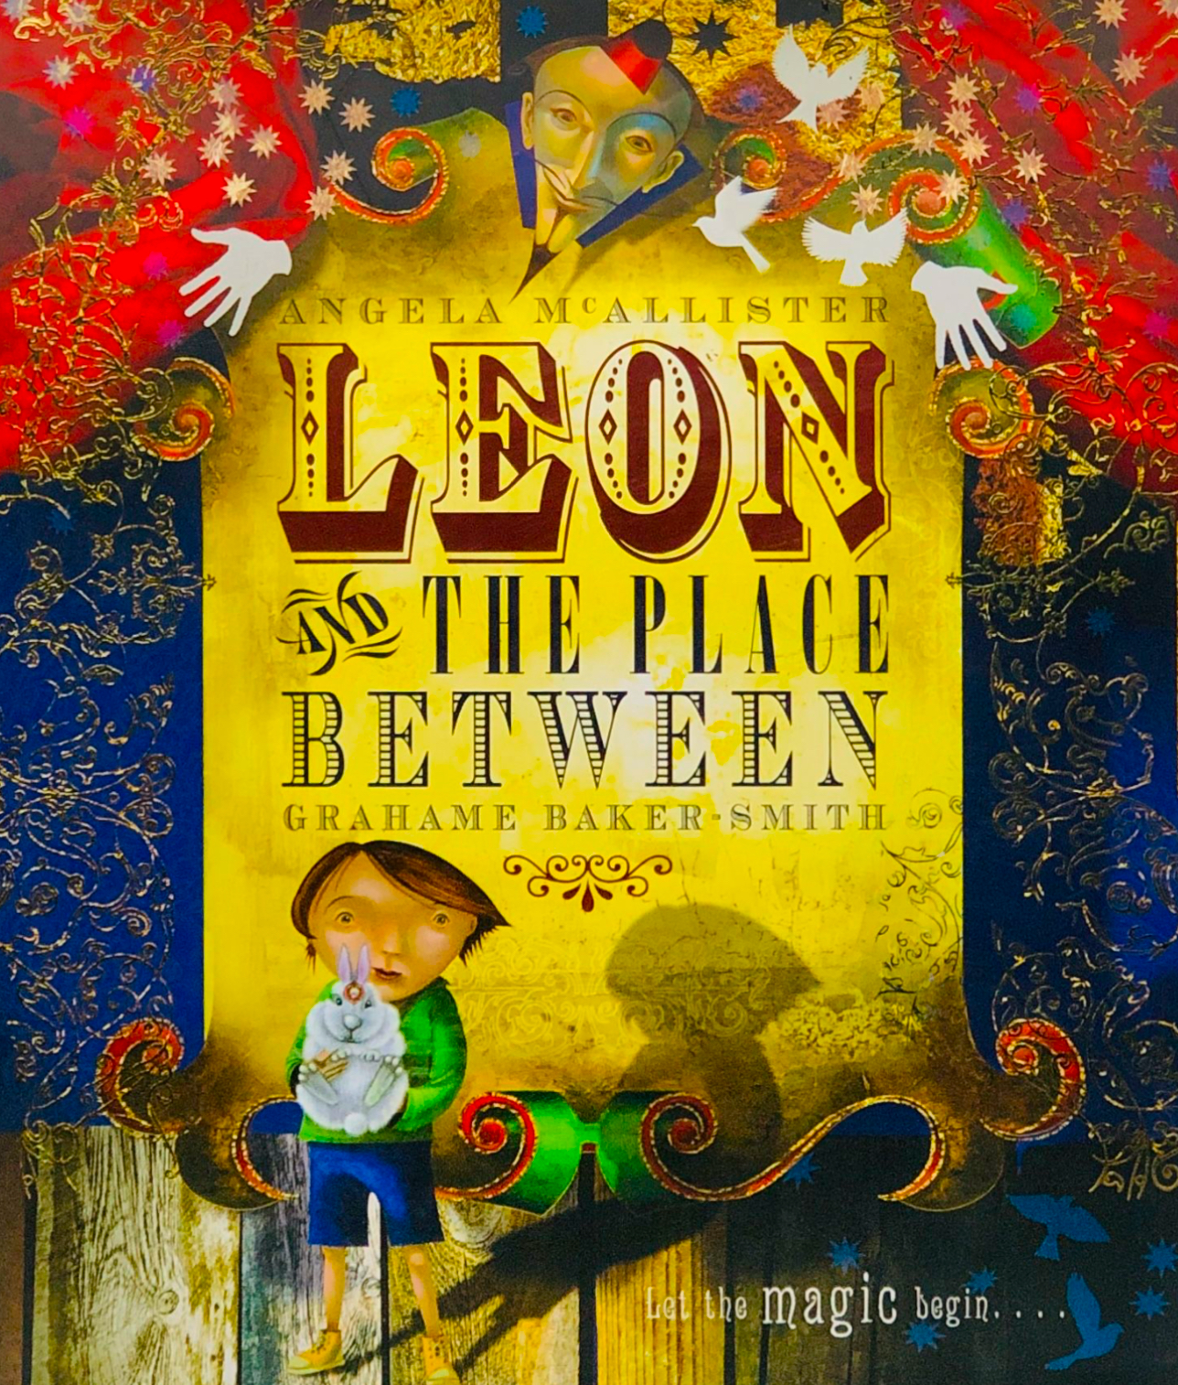**Writing**

Although I can’t reveal much about our writing unit, I can tell you that we will be writing diary entries based on a magical book called ‘Leon and the Place Between’. We will be learning about first person, past tense, onomatopoeia, personification and the ‘Action of 3’.

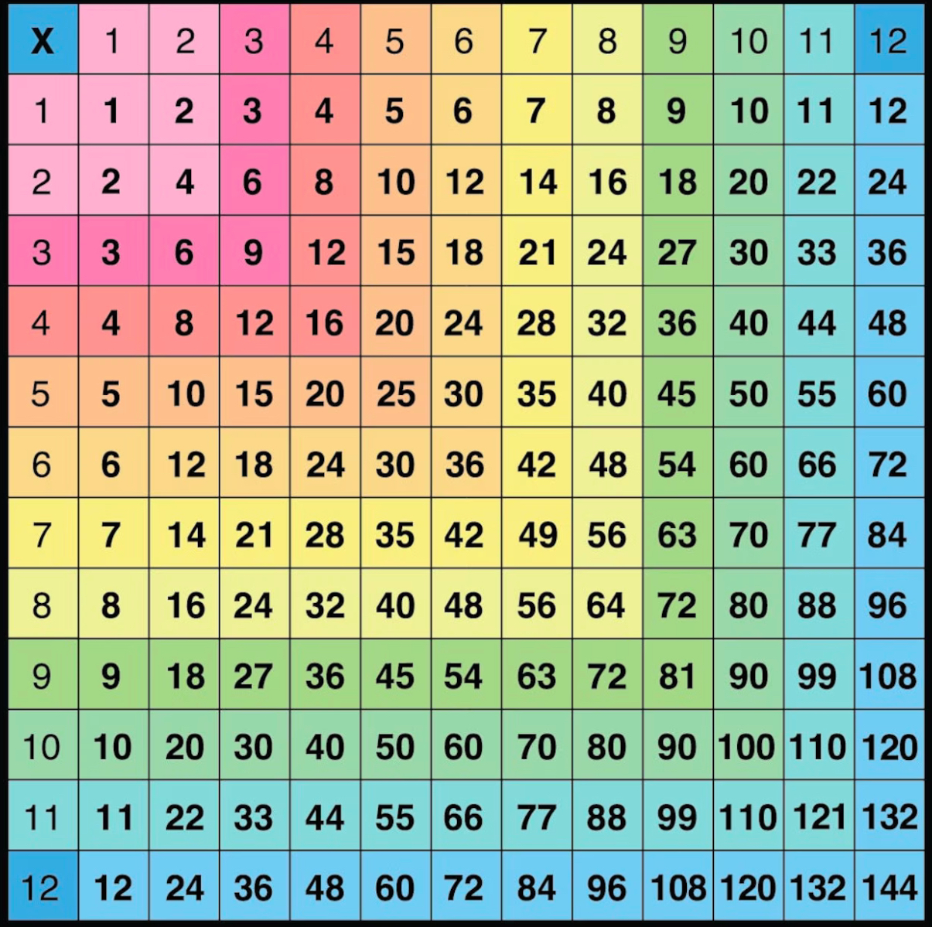**Maths**

We will be learning all about multiplication during autumn term 2. We will concentrate on the 3, 4 and 8 times tables. I will teach you about the quick strategies to work out answers and different ways to calculate. We will use lots of manipulatives to look at repeated addition too.

**Science**

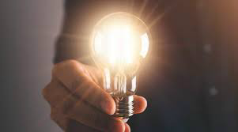We are going to be ‘lighting up’ in science and learning all about light. Learning about light sources and what they are will be a big focus. Looking at how shadows are made will be lots of fun and we will even get creative and make periscopes.

**Religious Education**

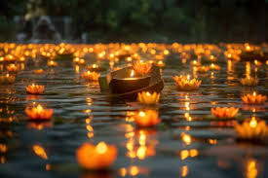Our RE unit this term will be all about ‘Festivals of Light’ in different religions. We will learn all about the importance of light in Christianity, Judaism and Hinduism.

**Physical Education**

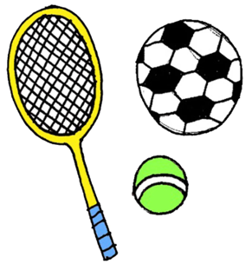Throughout our PE lessons this half term, our focus sports are going to be golf and gymnastics. In golf, we will learn all about technique and posture and how to hold a golf club or putter correctly. We will look at accuracy and hitting and chipping the golf ball. In gymnastics, we will look at different movements, postures and developing these into sequences.

**Art**

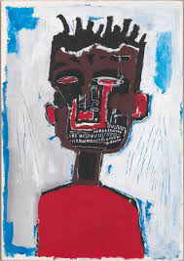Our fabulous art unit this term is all about mixed media. We will be learning about lots of different techniques that can be used to create different effects. We will focus on an artist called Jean-Michel Basquait and his work on portraits. Then, we will create a final piece based on his style.

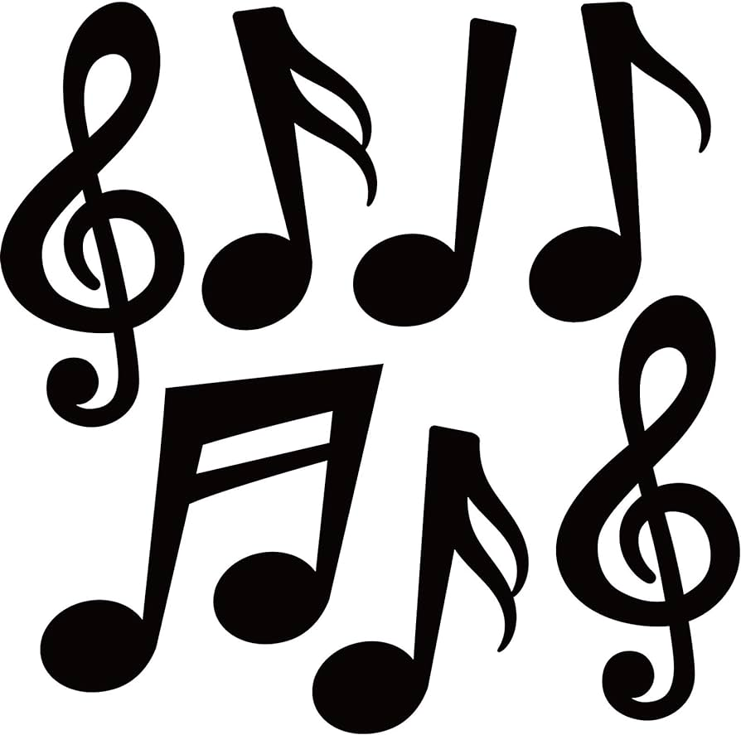**Music**

This half term, we are focusing on composition and building up to notation where children will learn to create their own piece of music, play a melody with reasonable accuracy and perform with confidence and in time with others. We will also have great fun listening to different styles of music and learning about the musical features.

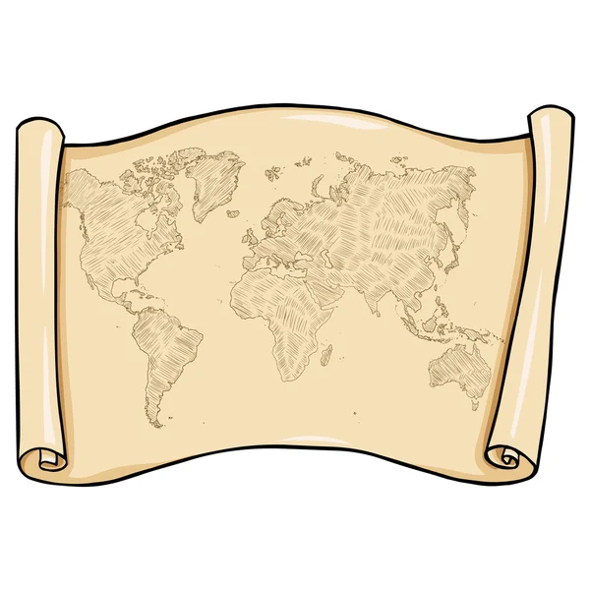**Geography**

We are beginning this term by practising our map skills and exploring different types of maps across the world! We will look at their features and purposes and have a go at reading and interpreting them, even drawing our own! We will learn about the 8 points of the compass too.

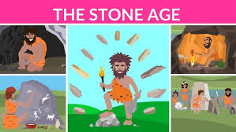**History**

We are going way back in time to learn all about the Ancient Egyptians. We will look at significant dates on the Ancient Egyptian timeline. The River Nile was so important to Ancient Egyptians for many reasons which we will be finding out about. We will learn about Egyptian artefacts, the pyramids and even the gory mummification!

**Design Technology**

In Design Technology, we will be exploring the use of textiles. We will look at different designs and evaluate them. After that, we will then become designers and makers ourselves!

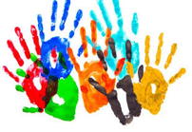**PSHE**

In PSHE, we will be thinking and celebrating all our our differences. We will be learning about what makes us unique and special but also how we have lots of similarities too. We will look at different families and what makes a family, whether that be in school, at home or different clubs. I can’t wait to find out about what makes you all super special!

**Computing**

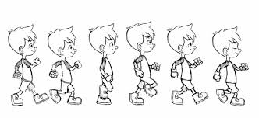This autumn, the children will be learning all about animation. We will look at how animation works and how pictures move. Making our own flip books will help us to find out how we can create our own animations on our iPads!