**What am I learning about this half term?**

**Reading**

We start the spring term off with a whole-school book focus. It’s top secret so I can’t tell you anything about it yet but I know Year 3 will love it! Our reading lessons this half term will be focusing on non-fiction texts. We will be looking at a variety of texts and finding their features. We will also learn how to write our own amazing non-fiction texts.

**Writing**

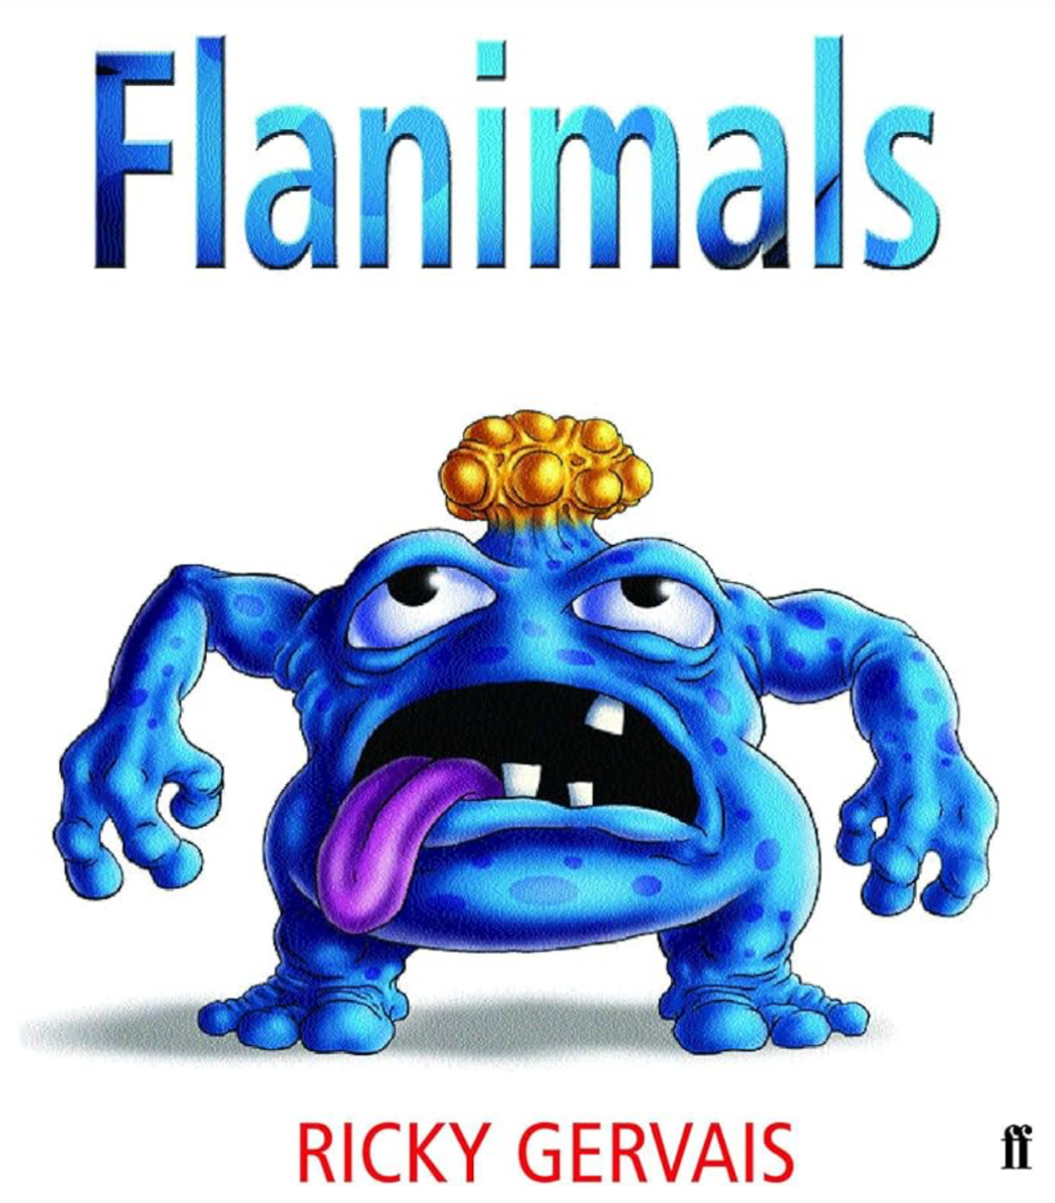We will also be focusing on our whole-school book for our writing lessons for the first week back. Then in writing this term, we are looking at another exciting book called ‘Flanimals’. Sounds interesting and strange doesn’t it?! I’m not going to tell you yet what it’s all about but we will be learning to write explanation texts.

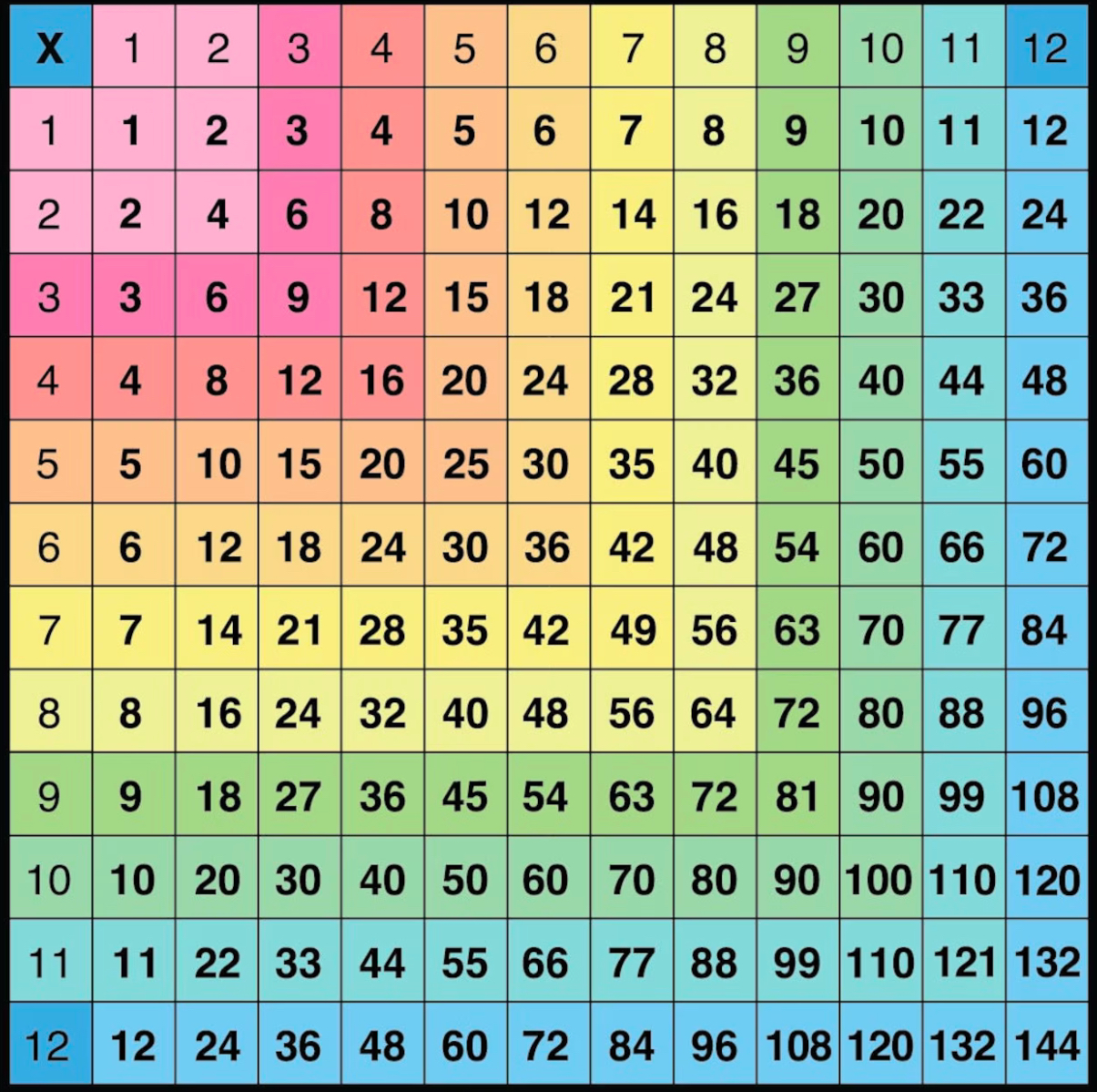**Maths**

We will be learning all about further multiplication and division during autumn term 2. We will concentrate on the 3, 4 and 8 times tables and their corresponding division facts. Different methods to multiply and divide effectively will be learnt.

**Science**

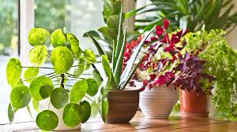Hopefully the weather will get warmer as we are going to be learning all about plants! We will be learning about the best conditions to grow plants in and we will even have a go at growing plants after planning an investigation. It will be great fun learning about the life cycle of flowering plants too!

**Religious Education**

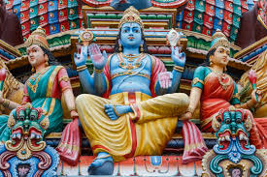Our RE unit this term will be all about ‘What Do Hindus Believe?’ We will learn about Brahman and their representations. We will get to plan a party meal and learn all about the Hindu diet. I am looking forward to seeing what tasty treats you can come up with!

**Physical Education**

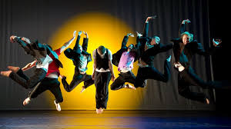Throughout our PE lessons this half term, our focus sports are going to be dance and volleyball! Let’s hope you’re ready to bust out some moves in our dance lessons! Volleyball is also a fantastic sport and we will learn about different rules of the game and how to play.

**Art**

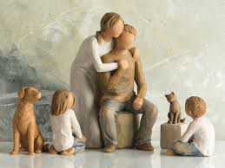Our wonderful art unit this term is all about ‘Family Life’. We will look at different artwork that has been created over time which is based on families. We will learn all about how to create our own family life sculpture and then make our own using wire. Focusing on the popular ‘Willow Tree’ sculptures will help us with ideas.

**Music**

This half term, we will be focusing on composing and using our imagination to create music. We will look at the building blocks of music and how pieces are put together. I can’t wait to hear your own compositions.

**Geography**

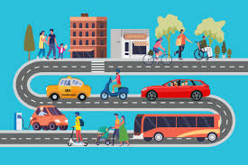We are going to be learning about transportation. Are you ready to hop on the bus and learn about the most frequently used modes of transport and their advantages and disadvantages? Can we classify types of transport and suggest ways to reduce pollution in cities?

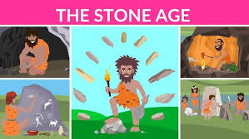**History**

We are going way back in time to learn all about the Ancient Egyptians. We will look at significant dates on the Ancient Egyptian timeline. The River Nile was so important to Ancient Egyptians for many reasons which we will be finding out about. We will learn about Egyptian artefacts, the pyramids and even the gory mummification!

**Design Technology**

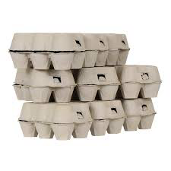In Design Technology, we will be exploring shell structures and how different products are created. We will test them out and look at their function and strength.

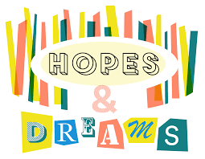**PSHE**

In PSHE, we will be thinking about our own personal dreams and goals. We will think about small hopes but also larger dreams we may have for our future. We will also learn about different ways that we can make those ambitions and dreams come true! Achieving these may be challenging so we will also learn about different strategies that we can use to overcome any obstacles.

**Computing**

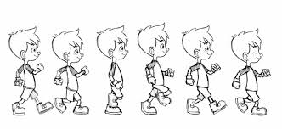This spring, the children will be learning all about animation. We will look at how animation works and how pictures move. Making our own flip books will help us to find out how we can create our own animations on our iPads!