What am I learning about this half term?

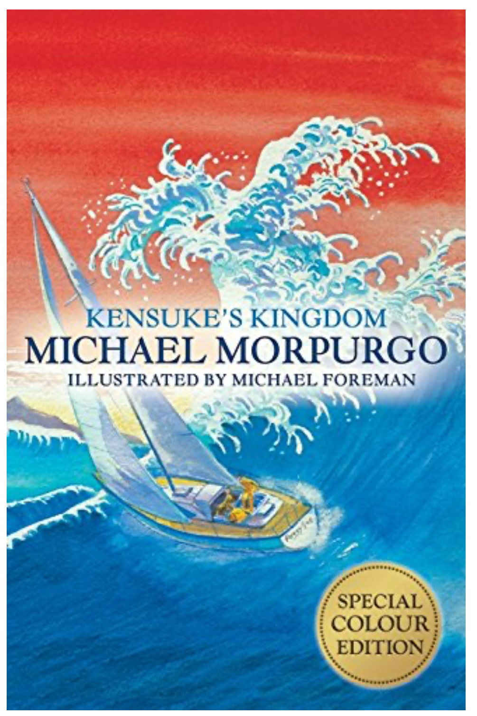
Reading and Writing
In the Summer term we will be exploring ‘Kensuke’s Kingdom’ by Michael Morpurgo. The children will be immersing themselves in island life and the adventures of Michael, Stella and Kensuke. While they continue to develop their retrieval and inference skills during our reading lessons, the children will also be testing their informal letter writing and instruction writing skills!

Maths
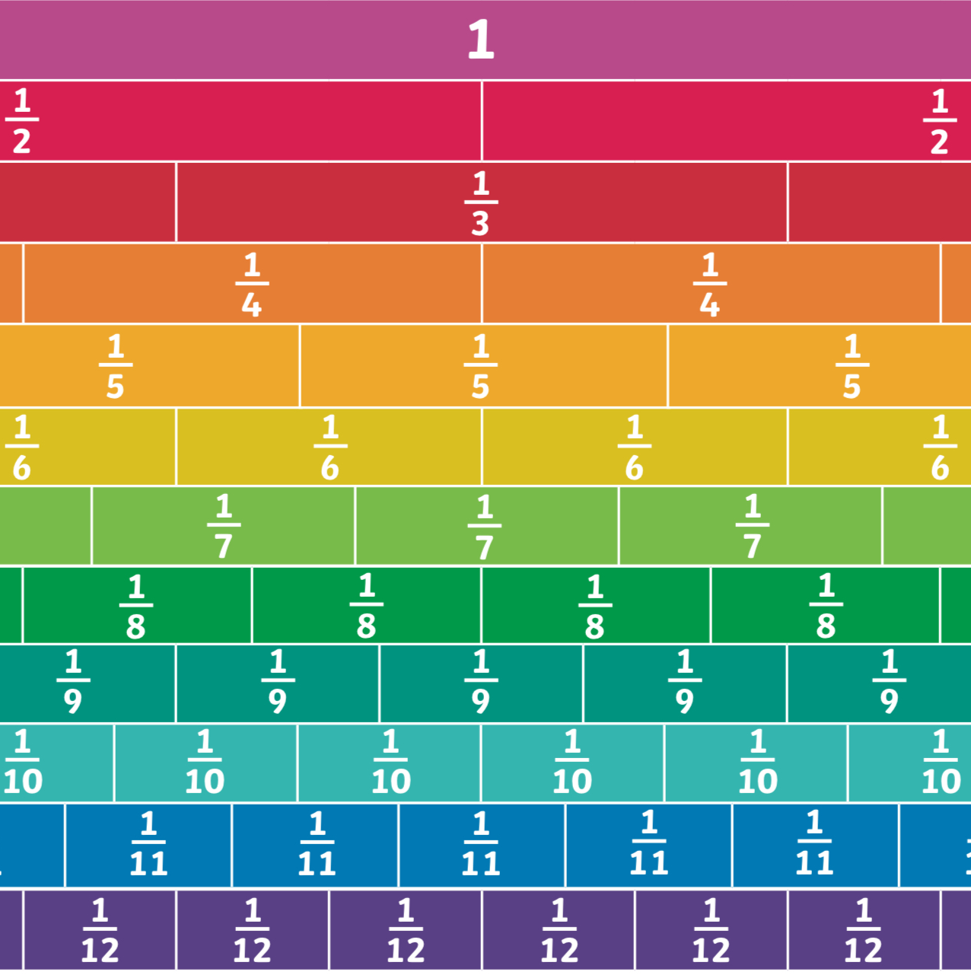
In the summer term 1, Year 4 are finishing their fractions chapter, followed by time. The children will continue to use a range of representations, including bar models, fractions walls, fraction strips and hundred squares, to support their learning. As always, we will also be applying our learning to a range of problem solving and reasoning activities. We will also be incorporating lots of times tables practice in preparation for the Times Tables Check!

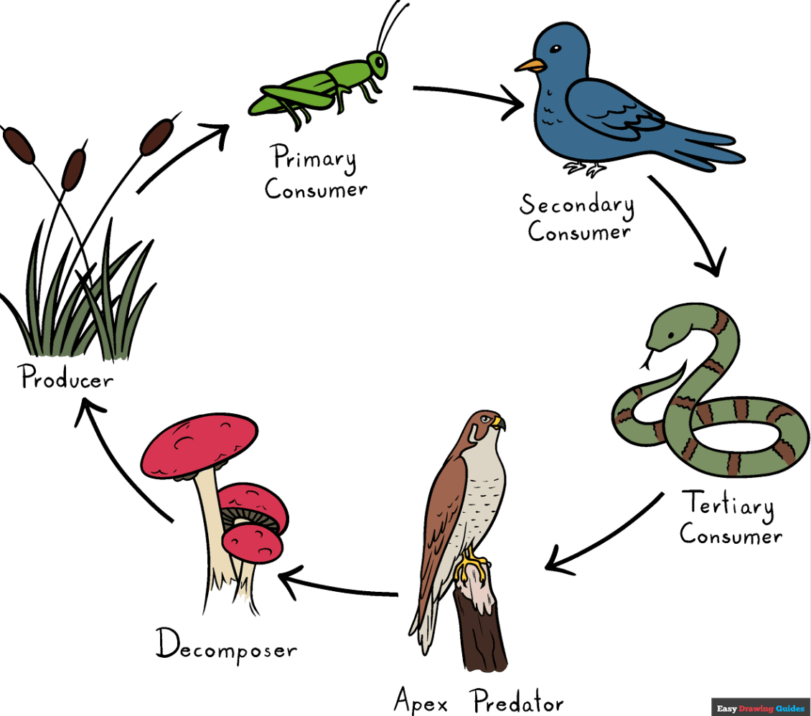
Science
In the Summer term, our new science topic is ‘Animals Including Humans’. We will be constructing food chains and identifying different types of teeth and their functions. Children will also be investigating how the human digestive system works!

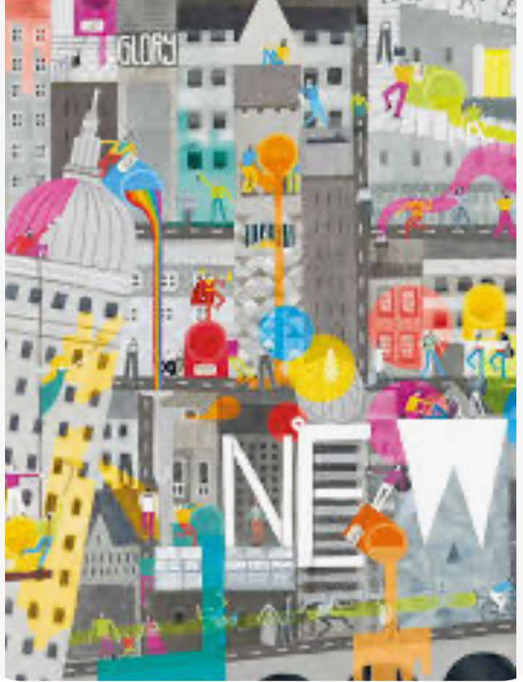
Religious Education
In our ‘Kingdom of God’ unit, we will be exploring the question, ‘What kind of world did Jesus want?’ Children will use parables, prayers and descriptions from the Bible, to decide what kind of person they think Jesus was and what he would want for us and for the world we live in.


Physical Education
In our PE lessons this half term, the children are going to participate in basketball sessions. Children will work on their ball control and developing accuracy when passing, shooting and receiving. They will also focus on developing their collaboration and communication skills.

Art
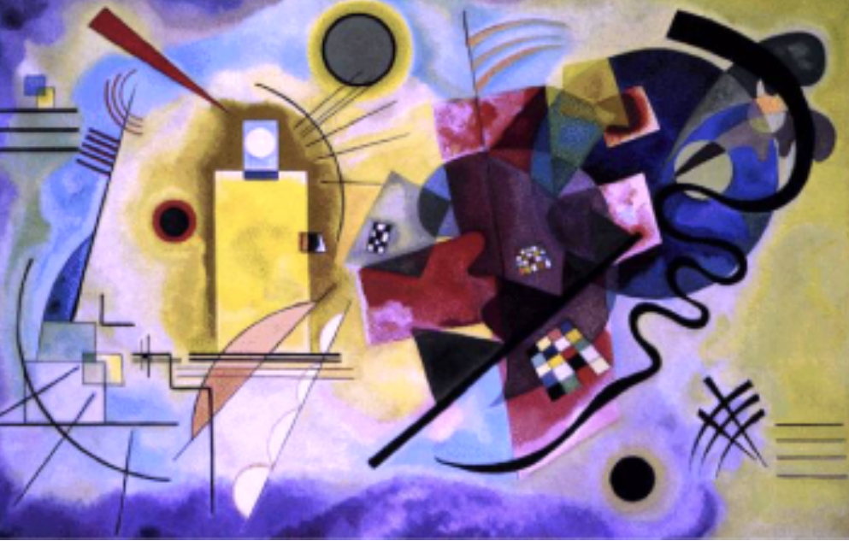
In our art unit this half term, we will be looking at abstract art, with reference to Kandinsky. Children will experiment with the use of shape and colour. They will even take inspiration from music, to create harmonious pieces of abstract art, as Kandinsky did.


Music
In the summer term, we are continuing to develop our knowledge of the interrelated dimensions of music, through our ‘Lean on me’ unit! We will be following the Charanga scheme, learning to listen and appraise various musical pieces, and of course we will be using our voices and instruments!


Geography
This half term, we are looking at the international trading of food, natural resources and tourism. The children will learn about how trading became global and what is meant by ‘fair trade’. They will then select and compile information about some of the most iconic historical tourist attractions in Europe!

History
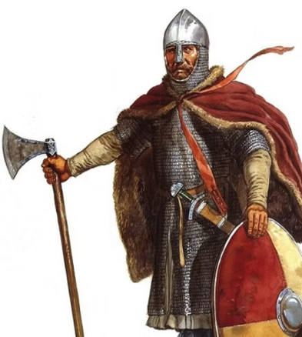
Welcome to the dark ages! We are continuing our timeline journey to find out why the Anglo-Saxons chose to unite their kingdoms in England, this term! Following on from our initial question, ‘What happened after the Roman army left Britain?’, we will examine the Battles of Edington and Stamford Bridge. The poem, Beowulf, will be discussed and the children will decide whether it really was a story told for pure entertainment…or not!

Design Technology
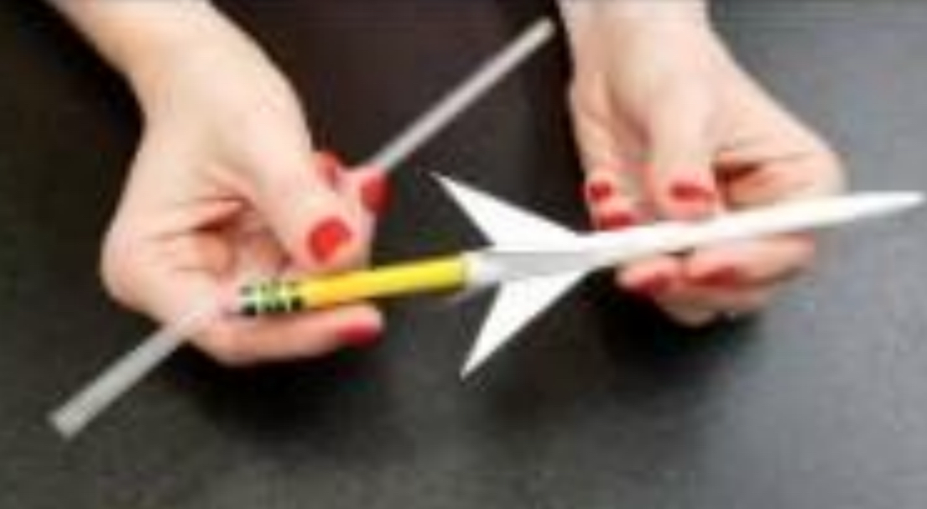
In Summer, our Design and Technology focus is ‘pneumatics’. The children will research pneumatics and create and test their own straw rockets! The children will have fun investigating how they can use straws, balloons and syringes to make objects move!

PSHE

In Summer Term, we are exploring ‘Economic Wellbeing’. We will follow the ‘My Happy Mind’ scheme, to discuss with the children the choices they make when spending money. We will examine the difference between needs and wants, and we will be learning about how we can keep track of our money, including saving and spending.

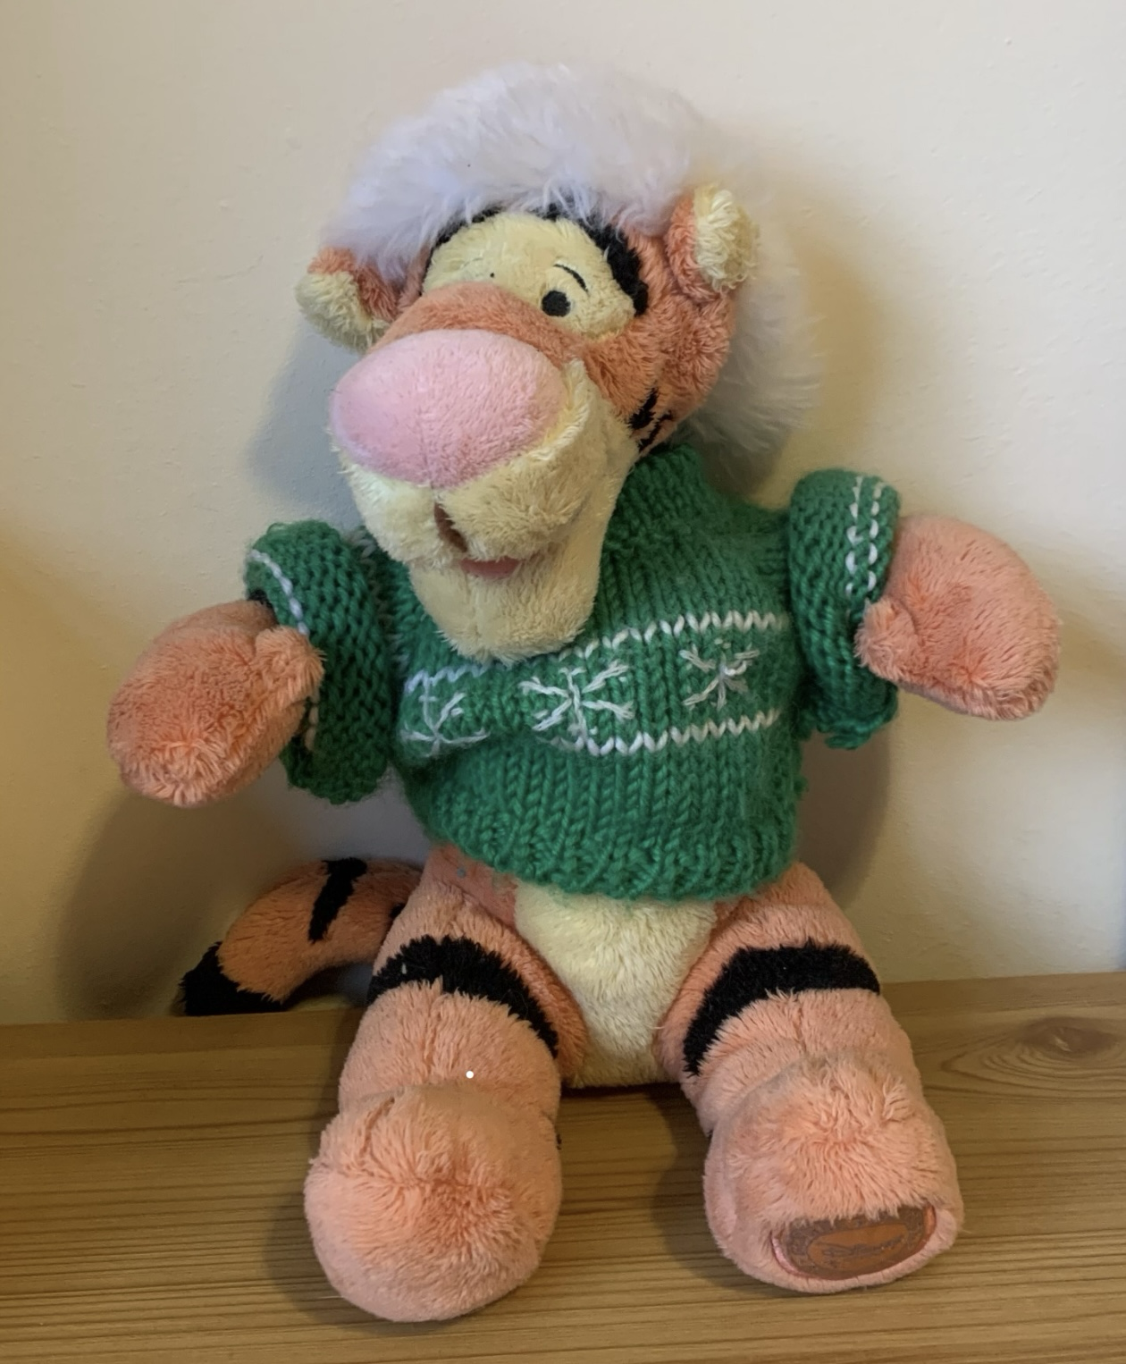
Computing
This summer, the children will be looking into photo editing. They will develop their understanding of how digital images can be changed and edited. They will consider the impact that editing images can have and will evaluate their choices.

