What am I learning about this half term? (Summer 1)

Reading
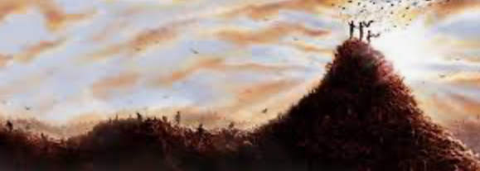
After concluding our unit of work on ‘The Good Thieves’, we will be moving onto a new novel which has equally as many twists and turns. From the start, this book will grab children’s attention and make them want to read more. It’s written in sections, with each one told by a different character, from a different perspective - each character giving more clues to how the story will unfold. There’s lots of action and lots of jeopardy too!
Writing
We will find out about the characters, their relationship with each other, and the lives that they lead, which will help us to write a newspaper report about a key event in the book. Children will also create a piece of persuasive writing, for a real purpose, that again links directly with some of the harsh realities of life that are highlighted in this novel.

Maths
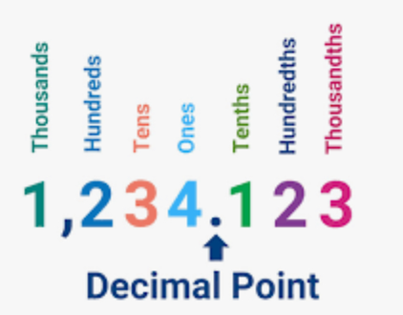
We will be working through the unit on decimals this term. Children will be linking fractions with decimal, as well as rounding, adding and subtracting 2-place decimals. We will continue to have daily ‘Fluency Five’ activities, which focus on mental maths strategies, and weekly retrieval tasks and problem solving activities.

Science
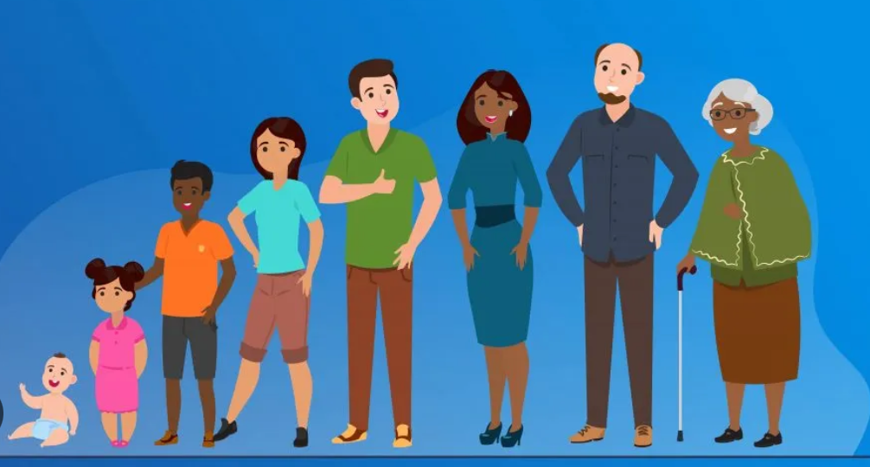
This term’s topic will be ‘Animals including Humans’. This unit will focus on growth and physics changes that occur throughout the human lifecycle, as adults develop into old age. Children will learn about gestation periods, how they are different for different animals and how they compare to humans.

Religious Education

For RE this term, children will be learning: ‘What kind of king was Jesus?’. For this unit, we will be exploring different biblical texts, as we think about why Jesus came to Earth and why he told parables - what effect did he hope to have? As ever, there will be plenty of opportunities for children to discuss their ideas and thoughts, in a range of contexts.
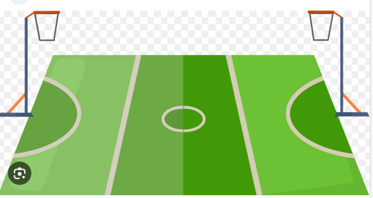
Physical Education
Through our PE lessons this half term, the children will continue to build up their fundamental skills and understanding of which components contribute to a healthy lifestyle. For our first unit, children will be exploring games and activities that really focus on their fitness. Our other unit is netball, where children will learn the key skills and rules, enabling them to work effectively and efficiently in a team.

Art
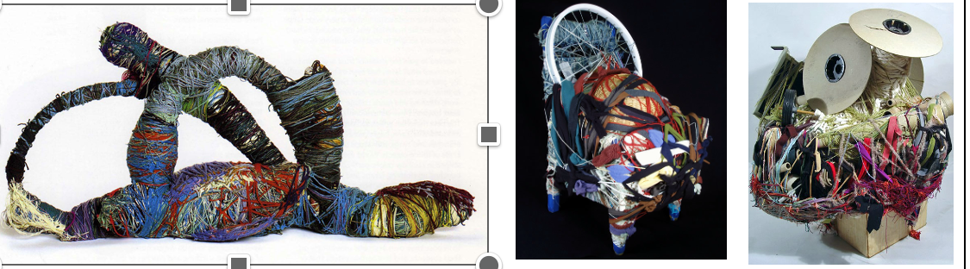
For this term’s unit, children will be creating sculptures that have been inspired by looking at the work of famous artists. They will be learning about installation art, and thinking about the inspiration and meaning behind it. Children will be using a range of different materials to create their work.


Music
We will be focusing our music learning around the well-known song: ‘Dancing in the Street’. Through a variety of games and activities, children will learn about music elements such as: pulse, pitch and rhythm. As well as learning to sing, play, improvise and compose with this song, children will listen and appraise, and learn about the background and history of the song.

Geography
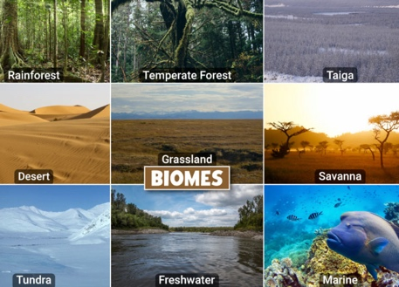
This term’s topic is ‘Climate and Biomes.’ Children will be learning about where some of the world’s biomes are located and what their characteristics are. We will also be considering the impact that human behaviour has had on some of the biomes studied.

History
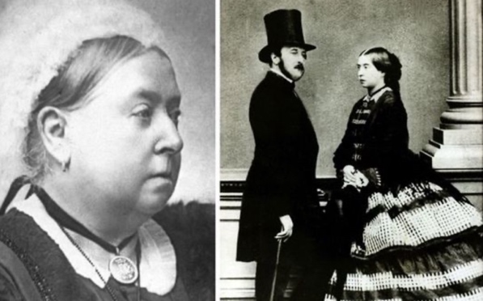
This term, we will be whisked back to the 1800s, to learn about the Victorian era. Queen Victoria and her empire will be our starting point, with following lessons looking at the hardships of Victorian times, including workhouses. As a contrast, children will be learning about the lives of rich children during Victorian times. We will also be loooking at the work of Charles Dickens and thinking about how his books were influenced by Victorian life. Out trip to Blists Hill Museum promises to be an immersive way to experience life as a Victorian.

PSHE
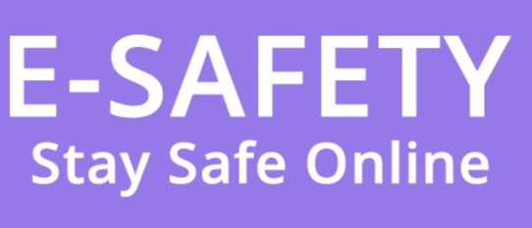
Children will learn about ‘Media Literacy and Digital Resilience’ for our PSHE unit of work. This will involve thinking about the benefits and disadvantages of using the internet and social media; how to make decisions about what is seen online and how reliable on-line information really is.

Computing

Children will be learning about video editing in this term’s unit. They will be taught how to create short videos by working in pairs or groups. As they progress through this unit, they will be exposed to topic-based language and develop the skills of capturing, editing, and manipulating video. Children will be guided with step-by-step support to take their idea from conception to completion. At the conclusion of the unit, learners have the opportunity to reflect on and assess their progress in creating a video.

