What am I learning about this half term?
Reading and Writing
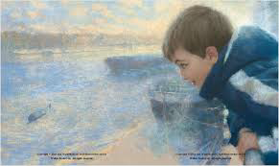
This term we are learning all about a fantastic book called ‘This Morning I Met a Whale’ by Michael Morpurgo. It is a fictional story inspired by a real event. A young boy encounters a whale on the Thames who has come to deliver a message about the Earth’s situation about the environment.

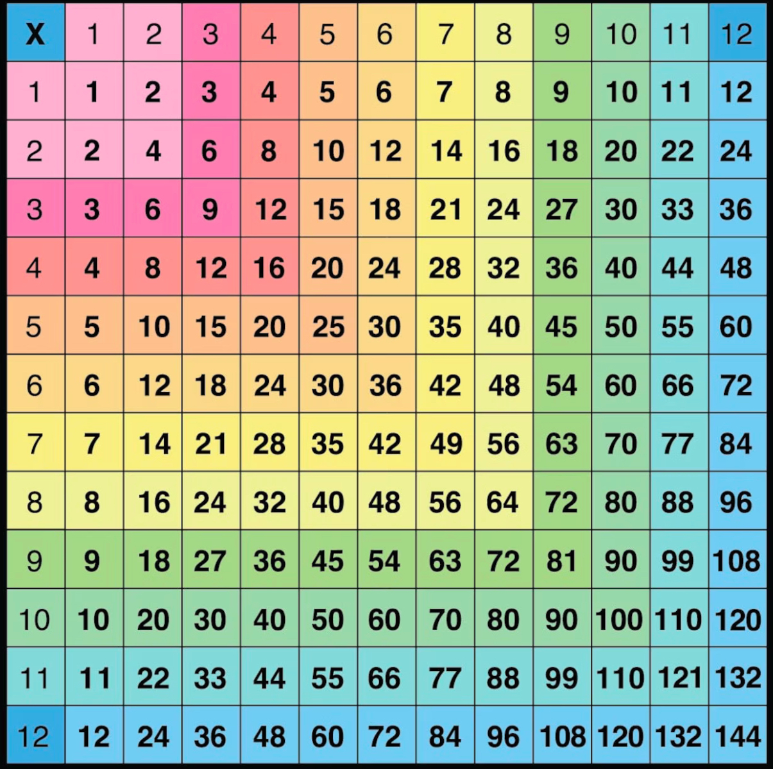
Maths
We will be having another busy term in maths and will be learning all about volume, money, time and graphs! We’ll be measuring the capacity of different liquids, looking at menus and how much meals cost and what change we would get and then learning to tell the time!

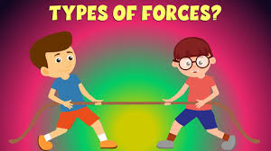
Science
How do we not float off into space? In our science lessons, we will be learning all about fantastic forces! I can’t wait to teach you about how magnets work and complete an investigation into a moving car!

Religious Education
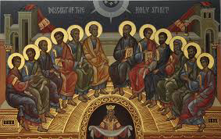
Our RE unit this term will be all about the Christian religion and Pentecost, ‘When Jesus left, what was the impact of the Pentecost?’ We will also be learning about the Christian belief about the Kingdom of God on Earth.

Physical Education
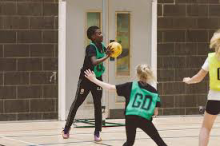
Throughout our PE lessons this half term, our focus sport is going to be netball. We will also be learning all about fitness. I’m looking forward to teaching you some of my bootcamp exercises! I’ve always fancied doing a personal training session! In netball we will be learning all about different passes and the rules of a netball match.

Art
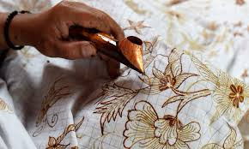
We’re going to be exploring the work of Richard Kimbo and learning how to create batik pieces of work using wax! We will look at Maya patterns and then create our own design to then make.


Music
This half term, we will be focusing on composing and using our imagination to improvise and try playing things on the spot. We will use different instruments including tuned and untuned percussion.

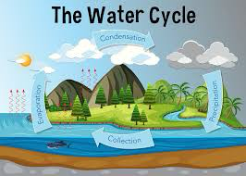
Geography
Learning how the water cycle works will be interesting and you’ll be able to explain why and how it rains. We will also learn all about cloud formations and even have a go at creating some artwork based on them.

History
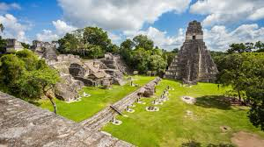
We are going way back in time to learn all about the Ancient Myan world. The buildings and artwork they created were amazing! The Myan people also invented many different things that we still use today…let’s find out what…

Design Technology
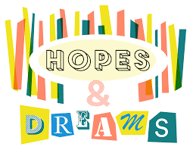
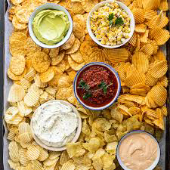
In Design Technology, we will be exploring one of my favourite snacks…chips and dips! We will be taste testing, designing and creating out own dips. Yum, yum!
PSHE
In PSHE, we will be thinking about our own personal dreams and goals. We will think about small hopes but also larger dreams we may have for our future. We will also learn about different ways that we can make those ambitions and dreams come true! Achieving these may be challenging so we will also learn about different strategies that we can use to overcome any obstacles. We are going to be learning about money too!

Computing
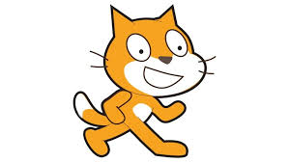
This summer, we will be learning all about programming and how devices work. We will be inputting instructions and controlling our own Sprites. We will look at when things go wrong in programming (Uh, oh!) and how they can be fixed.

